**Working with User Defined Harness:**

**Add New Harness Rule.**

**Req: In Customer Search form after giving cust ID & when you search for Cust ID, Display Customer Results in a New Pop up Window.**

**Open Customer search Section:**

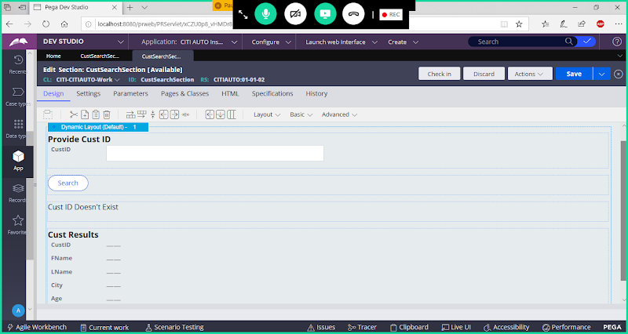

**Delete Label & Customer Results Section**

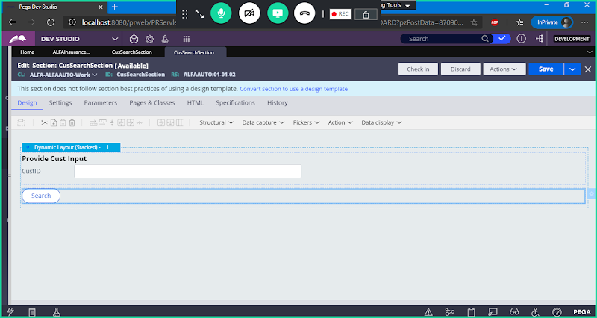

**Save section**

**Add New Harness for Customer Results section:**

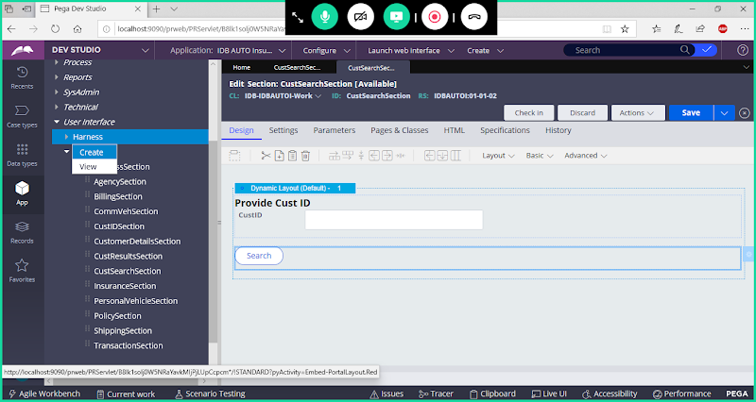

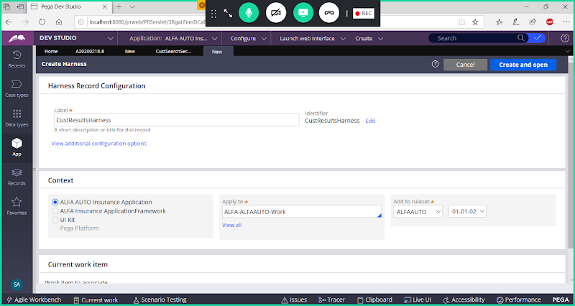

**open**

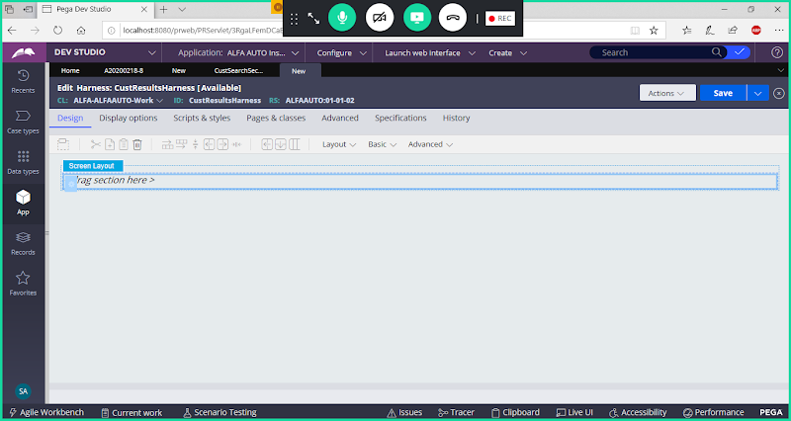

**Open Panel Settings**

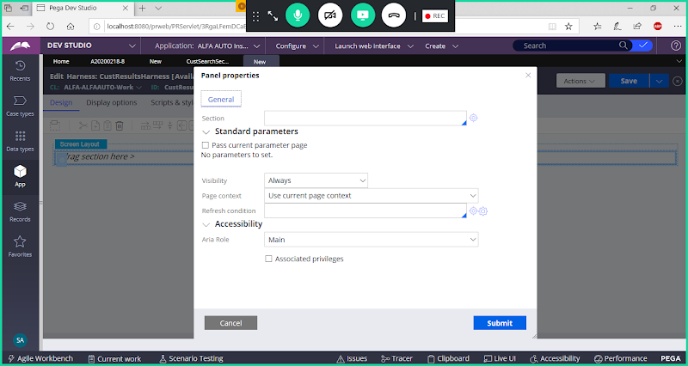

**Select Section Name: CustResultsSection**

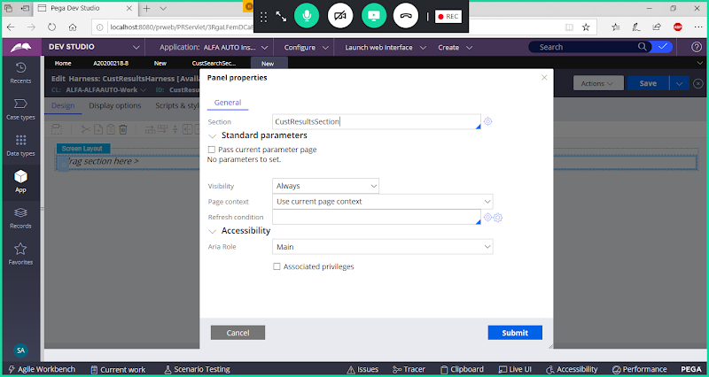

**Submit**

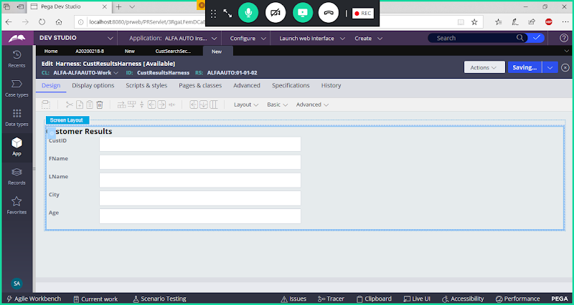

**Save Harness**

**Call Harness Rule in Search Button Settings under Customer Search Section**

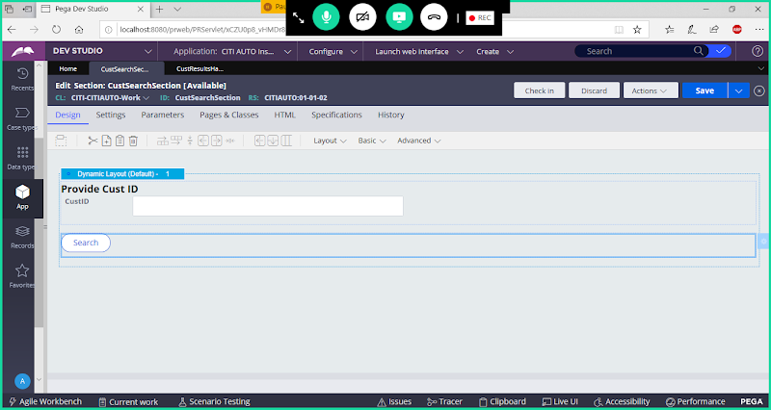

**Double Click on Button**

**Go to Actions tab:**

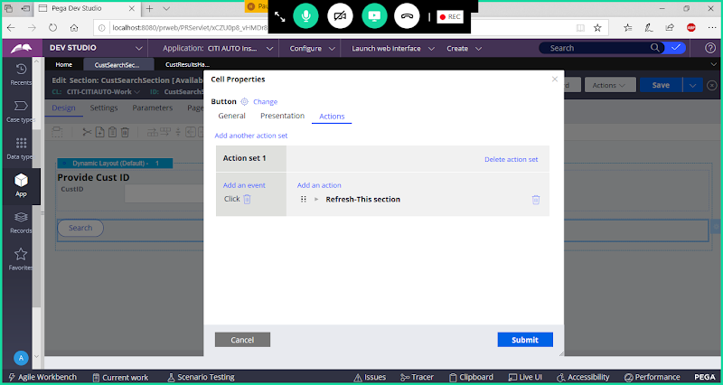

**Add one more Action**

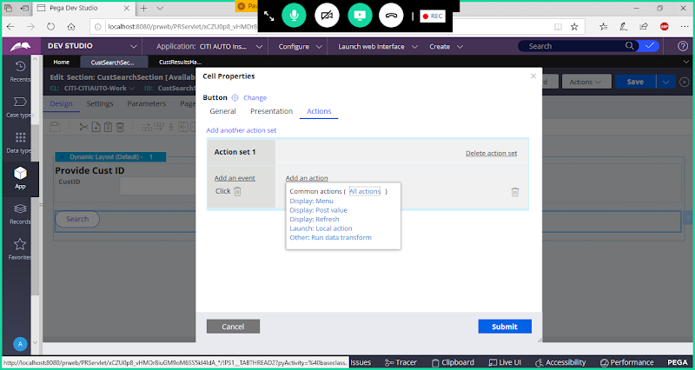

**Action Name: Launch Harness**

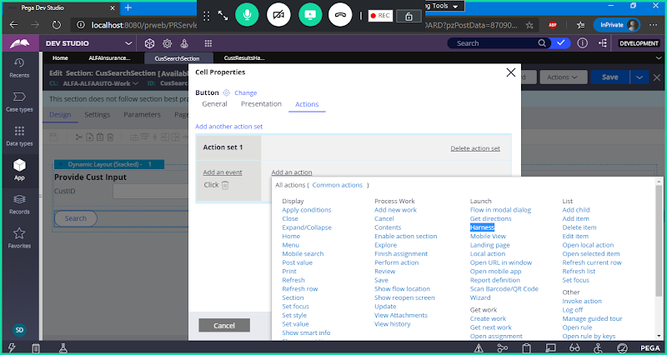

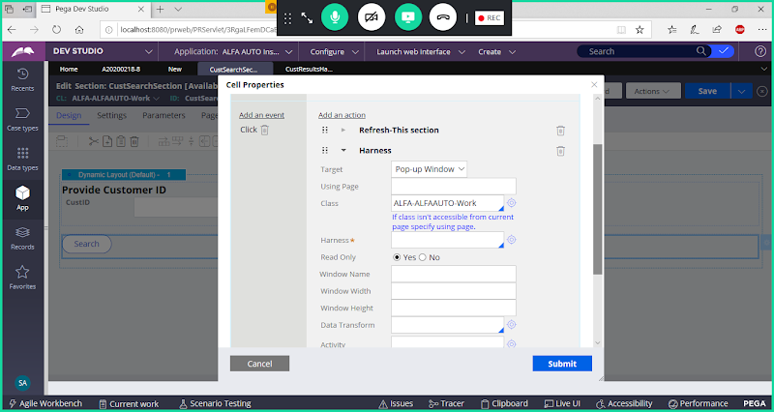

**Give Harness Name**

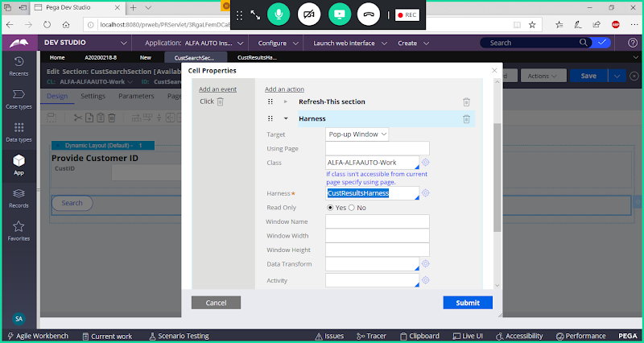

**Submit**

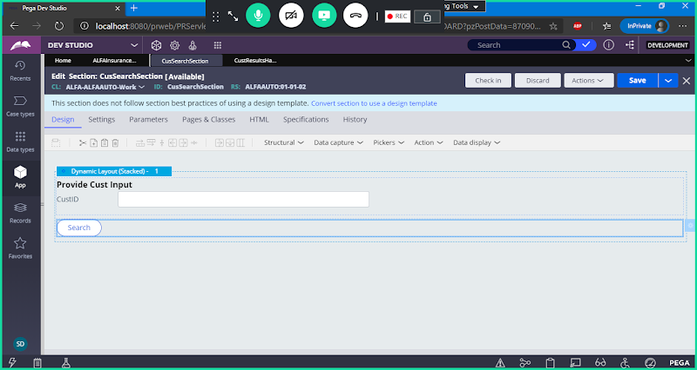

**Save section & Check in**

**Run Flow & Test the cust results in New Harness**

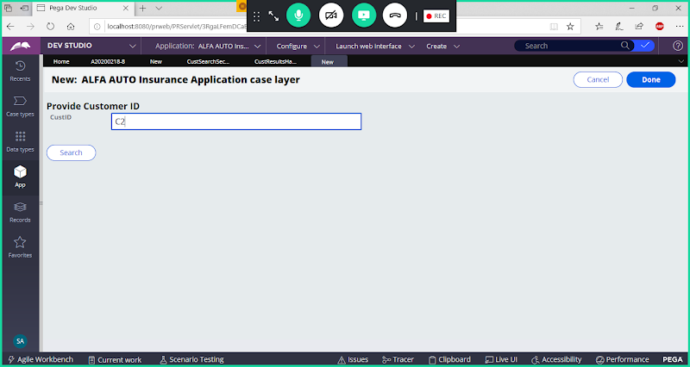

**Search**

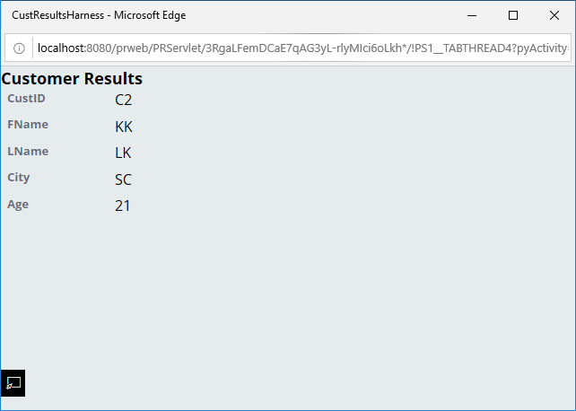

**Diff b/w Local Action & Harness?**

**LocalAction:**

**In Local Action we can call only Single Section**

**Using Local Actions we Cannot access data from other applications**

**Only Internal Application Pages we can Access**

**The Results will display in Overlay /Model Dialog/Replace Current Page format**

**Harness:**

**In Harness we can call one or more Sections**

**Using Harness we can access data from External applications & also from Internal Application we can load**

**It will load data in a separate browser window.**

**The display format is Replace Current Page, Pop Up Window &  New Document ( Menu )**

**Task: Same requirement try using Local Action Rule ( Display Model Dialog Box)**